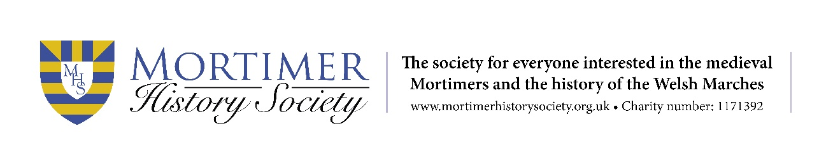
Mortimer History Society Bursary 2024 Application Form
Closing date for applications is 30 June 2024
Please send the completed form to: bursary@mortimerhistorysociety.org.uk
1) Your Name, Address and email address

2) Your Institution, your course, the length of course and when you started

3) The subject of your thesis/research, and please also provide an abstract of your proposed thesis in no more than 500 words

4) Your supervisor’s name, their position, and their email address

5) Your research plan for the year

6) What will the bursary enable you to do, and what will the benefits be for you? 300 words maximum.

7) Signature

Date

